SELECT mcdata_col_1
FROM zds_5657E707000F704620

Querying MasterControl Data Structures

- Once a Data Structure has been created, discover its ID by hovering over any of the icons in the Data Structures list and looking in the Status Bar at the bottom (must be enabled in your browser). Also, you can right-click on the icon and choose Copy Shortcut.

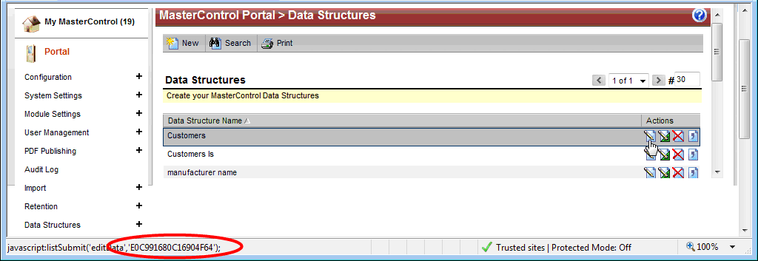

In this case, the ID for the Customers Data Structure is E0C991680C16904F64.

- In the SQL query, the table name will be zds_ plus the ID of the Data Structure. In this example, the table name is zds_E0C991680C16904F64. The column names are referenced by naming them mcdata_col_ followed by the number of the column (from left to right). So the column name for CustomerName would be mcdata_col_1, the column name for Address would be mcdata_col_2, and so forth.

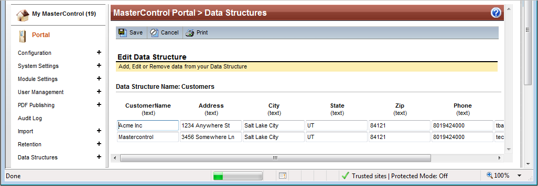
- In External Datasources, construct your query by using the appropriate Name and Source (see the External Datasource instruction). Then construct your query as desired.

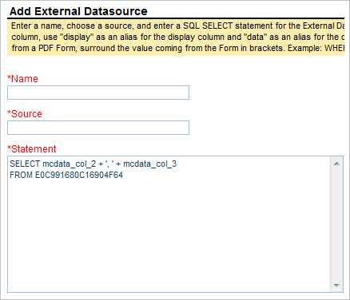

- If you want the display value and export value to be different, use “display” and “data” as aliases.

